2010 H1 CHEMISTRY PRELIMINARY EXAMINATION PAPER 2 ANSWERS

Section A

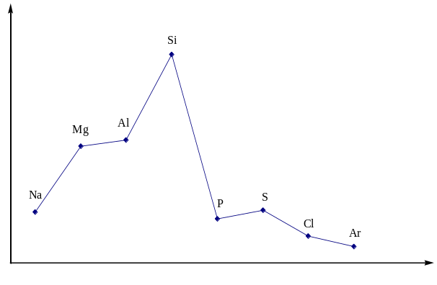1(a)
Melting Point

Na, Mg, Al:
High melting point due to strong metallic bond.
Melting point increases from Na to Al due to increase in valence electrons.

Si:
High melting point due to giant molecular structure.
It involves breaking of strong covalent bonds.

P₄, S₈, Cl₂, Ar:
Low melting point due to weak dispersion forces between molecules/atoms.
Dispersion forces depends on the number of electrons in molecules. Hence, melting point decreases in the order S₈ > P₄ > Cl₂ > Ar.

(b)(i)
1s² 2s² 2p⁶ 3s² 3p⁴

(ii)
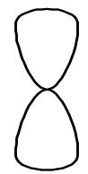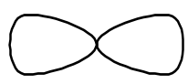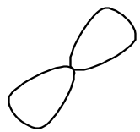
x
y
z
3s
x
y
z
3p_{x}
3p_{y}
3p_{z}

(iii)
E is sulfur.
First I.E. of E is lower than that of D as less energy is required to remove the 3p⁴ electron which experiences interelectronic repulsion.

(c)(i)
6Fe²⁺ + Cr₂O₇^{2–} + 14H⁺ → 6Fe³⁺ + 2Cr³⁺ + 7H₂O

(ii)
No. of moles of Fe²⁺ used
= 0.050 x 40.0 x 10^{–3}
= 2.00 x 10^{–3} mol

From equation, no. of moles of Cr₂O₇^{2–}
= 2.00 x 10^{–3} / 6
= 3.33 x 10^{–4} mol

Total no. of moles of Cr₂O₇^{2–}
= 0.10 x 50.0 x 10^{–3}
= 5.00 x 10^{–3} mol

No. of moles of Cr₂O₇^{2–} reacted with 100 cm³ of polluted water sample
= 5.00 x 10^{–3} – 3.33 x 10^{–4}
= 4.67 x 10^{–3} mol

(iii)
No. of moles of Cr₂O₇^{2–} reacted with 1 dm³ of polluted water sample
= 4.67 x 10^{–3} x 10
= 0.0467 mol (allow ecf)

(iv)
O₂ + 4H⁺ + 4e– → 2H₂O
Cr₂O₇^{2–} + 14H⁺ + 6e– → 2Cr³⁺ + 7H₂O

Equivalent no. of moles of O₂
= x 0.0467
= 0.0700 mol

(v)
Cr₂O₇^{2–} + 14H⁺ + 6e– → 2Cr³⁺ + 7H₂O
C₆H₁₂O₆ + 6H₂O → 6CO₂ + 24H⁺ + 24e–
4Cr₂O₇^{2–} + 32H⁺ + C₆H₁₂O₆ → 8Cr³⁺ + 22H₂O + 6CO₂

2(a)(i)
Heat evolved
= 200 x 4.18 x 46.9 x 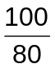 [–½ m if missing 100/80]
= 49000 J or 49.0 kJ

Amount of cyclobutane used
= 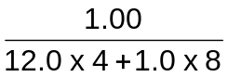
= 0.0179 mol
ΔH_{c}(cyclobutane)
= –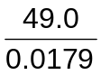
= –2740 kJ mol^{–1}

(ii)
ΔH₁ = ΔH_{c}(cyclobutane) – 2ΔH_{c}(CH₂=CH₂)
= –2740 – 2(−1422) (ecf)
= +104 kJ mol^{–1}

(b)(i)
The heat change when one mole of ethanol is formed from its constituent elements in their standard states at 298 K and 1 atm.

(ii)
ΔH = ΣBE(reactants) – ΣBE(products)
= 3(436) + ½(496) – (350 + 5 x 410 + 360 + 460)
= –1664 kJ mol^{–1}

(iii)
–276 kJ mol^{–1}
2C(s) + 3H₂(g) + ½O₂(g) CH₃CH₂OH(l)

+39 kJ mol^{–1}
2ΔH_{at}
–1664 kJ mol^{–1}

2C(g) + 3H₂(g) + ½O₂(g) CH₃CH₂OH(g)

By Hess’ Law,
2ΔH_{at} = –276 + 39 – (–1664)
= +1427 kJ
ΔH_{at} = +713.5 kJ mol^{–1}

(c)(i)
Step 1
Reagents: H⁺ / K₂Cr₂O₇
Conditions: distil

Step 2
Reagents: HCN, NaCN catalyst
Conditions: room temperature

(ii)
B: CH₃CH(OH)CO₂H

C: CH₃CH(OH)CO₂CH₂CH₃
3(a)(i)(I)
Reagents: HCN, NaCN catalyst
Conditions: room temperature

(II)
Reagents: alkaline KMnO₄
Conditions: room temperature

(ii)
Geometric isomerism
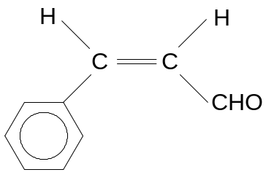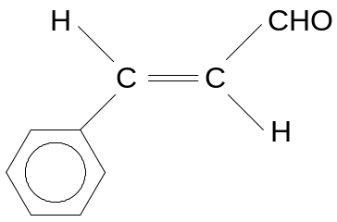
cis trans

(iii)
An orange precipitate is seen.
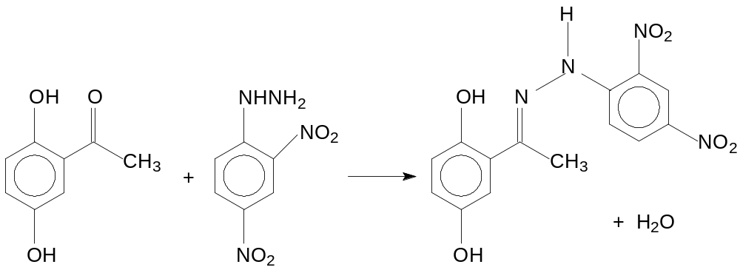

(iv)
Reagents: alkaline aqueous I₂
Conditions: warm (< 70 ºC)
Observation: Yellow ppt (CHI₃) formed for acetylhydroquinone and no yellow ppt formed for vanillin.

[OR Tollen’s reagent, heat, Ag mirror formed for vanillin only (no reaction with Fehling’s solution)]

(b)(I)
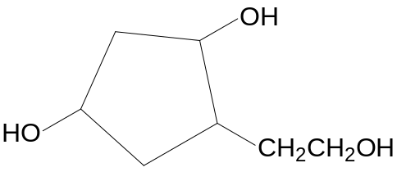
Na⁺ –O₂CCH₂CH=C(CH₃)₂

(II)
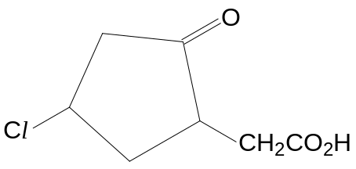
CH₂(CO₂H)₂
(CH₃)₂CO

Section B

4a(i)
K_{c} = 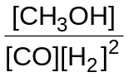

(ii)
 | CO(g) + | 2H₂(g) | ⇌ | CH₃OH(g)
Initial / mol | 2 | 6 |  | 0
Change / mol | –1.7 | –3.4 |  | 1.7
Equilibrium / mol | 0.3 | 2.6 |  | 1.7

(iii)
K_{c} = 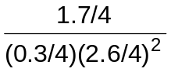 (ecf)
= 13.4 mol^{–2} dm⁶ (ecf)

(iv)
rate
time
0
forward reaction
backward reaction
forward reaction
backward reaction

(b)(i)
When temperature increases, the equilibrium amount of CH₃OH decreases.
The backward reaction is favoured.
By Le Chatelier’s Principle, the backward reaction is endothermic.
Hence, the sign of ΔH of the forward reaction is negative.

(ii)
Too low a temperature will result in a slow reaction rate,
rendering the process economically unviable / not cost effective.

(iii)
Addition of a catalyst.

(c)(i)
An acid is a proton donor.
A base is a proton acceptor.

(ii)
HClO + H₂O ⇌ ClO– + H₃O⁺

(iii)
K_{a} = 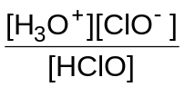

(iv)
K_{a} = (2.50 x 10^{–5})² / 0.0200
= 3.13 x 10^{–8} mol dm^{–3}

(d)(i)
A buffer solution resists pH change when a small amount of acid or base is added to it.

(ii)
Solution contains a high concentration of HClO and ClO–.
When a small amount of acid is added, ClO– neutralises it.
ClO– + H⁺ → HClO
When a small amount of base is added, HClO neutralises it.
HClO + OH– → ClO– + H₂O

5(a)
A undergoes addition reaction with Br₂ in CCl₄.
A contains one C=C double bond since it reacts with Br₂ in a 1:1 ratio.

A undergoes mild oxidation with cold alkaline KMnO₄ to give B, a diol.
Further oxidation of B gives C which has a carboxylic acid group as C can react with Na₂CO₃.
B contains a 1º alcohol.
C is not a carbonyl compound as it does not react with 2,4–DNPH.
B also contains a 3º alcohol.

A undergoes oxidative cleavage with hot acidified KMnO₄
to form a single organic product with one less carbon.
Hence, A is a terminal alkene.
A is 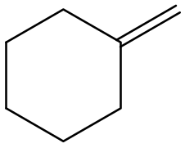.
B is 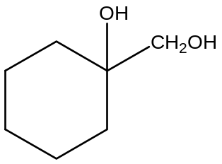.
C is 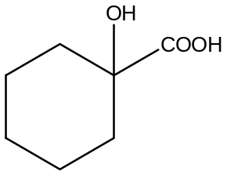.

D undergoes addition
to give cyanohydrin E.
D is a ketone.
D is 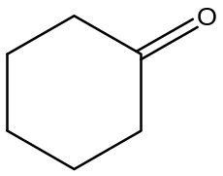.
E is 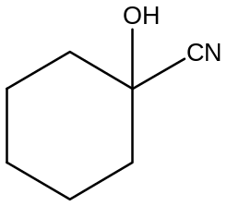 where it undergoes acidic hydrolysis will give C.

A undergoes Wacker Process to give F.
F contains an aldehyde group since it gives a positive test with Tollen’s reagent.
F does not contain an alkene group since it gives a negative test with Br₂(aq).
F is 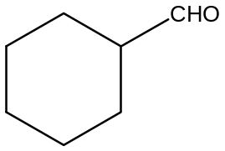.

(b)(i)
Comparing expts 3 and 4, (OR When [Br–] is doubled, rate is doubled.)
order wrt Br– = 1.

Comparing expts 2 and 3 after making total volume the same,
when [BrO₃–] is doubled, rate is doubled.
Order wrt BrO₃– = 1.
Comparing expts 1 and 2,
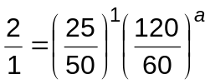 where a is the order with respect to H⁺.
a = 2
Order wrt H⁺ = 2.

Rate = k[Br–][BrO₃–][H⁺]²

(ii)
[Br–]
time
t_{1/2} constant

Graph 2:
Show twice [Br–] on the y–axis.
Show two constant half–life.

(iii)
number of molecules with a given energy
E_{a}’ E_{a} energy
T₁

At the same temperature T₁, a catalyst provides an alternative reaction pathway
such that the new activation energy E_{a}’ is lower.
There is a larger number of molecules with energy ≥ E_{a}’.
Hence, number of effective collisions per unit time increases and
rate increases.

6(a)(i)
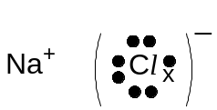
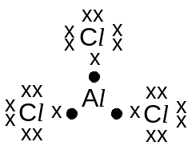

(ii)
Dative bond is formed where lone pair of electrons on N is donated into the empty orbital of Al.
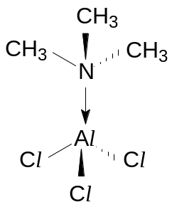

(iii)
Bond angle around N atom in (CH₃)₃N: 107º
Bond angle around N atom in the product: 109.5º (or 109º)

(iv)
MgCl₂ has giant ionic structure with ionic bonding between Mg²⁺ and Cl– ions.
PCl₃ has simple molecular structure with dipole–dipole attractions between molecules.
As ionic bonding is stronger than dipole–dipole attractions, the melting point of MgCl₂ is higher than PCl₃.
PCl₃ has covalent bonding instead of ionic bonding due to the low electronegativity difference between P and Cl atoms. Thus, sharing of electrons occurs. [OR PCl₃ has covalent bonding instead of ionic bonding as P has high electronegativity. Thus, sharing of electrons occurs.]

OR
MgCl₂ has ionic bonding instead of covalent bonding due to the high electronegativity difference between Mg and Cl atoms. Thus, transferring of electrons occurs. [OR MgCl₂ has ionic bonding instead of covalent bonding as Mg has low electronegativity. Thus, transferring of electrons occurs.]

(v)
MgCl₂ is an electrical conductor when molten due to presence of mobile ions while PCl₃ is not due to absence of mobile ions when molten.
[N.B. Both MgCl₂ and PCl₃ are able to conduct electricity in aqueous solution due to presence of mobile ions.]

(b)(i)
Y: Al
Z: P

The oxide of Y reacts with both NaOH and HCl. Hence, it is an amphoteric oxide.
Al₂O₃(s) + 6HCl(aq) → 2AlCl₃(aq) + 3H₂O(l)
Al₂O₃(s) + 2NaOH(aq) + 3H₂O(l) → 2NaAl(OH)₄(aq)
The chloride of Y undergoes hydration and hydrolysis
to form an acidic solution. Hence, it reacts with NaOH.
AlCl₃(s) + 6H₂O(l) → [Al(H₂O)₆]³⁺(aq) + 3Cl⁻(aq)
[Al(H₂O)₆]³⁺(aq) + H₂O(l) ⇌ [Al(H₂O)₅(OH)]²⁺(aq) + H₃O⁺(aq)

Phosphorus chloride and phosphorus oxide will react with water but silicon dioxide is insoluble in water.
PCl₃(l) + 3H₂O(l) → H₃PO₃(aq) + 3HCl(aq)
OR PCl₅(s)+ 4H₂O(l) → H₃PO₄(aq) + 4HCl(aq)
P₄O₆(s) + 6H₂O(l) → 4H₃PO₃(aq)
OR P₄O₁₀(s) + 6H₂O(l) → 4H₃PO₄(aq)

(ii)
Both the chloride and oxide of Z react with water to form solution with pH = 2.

(c)
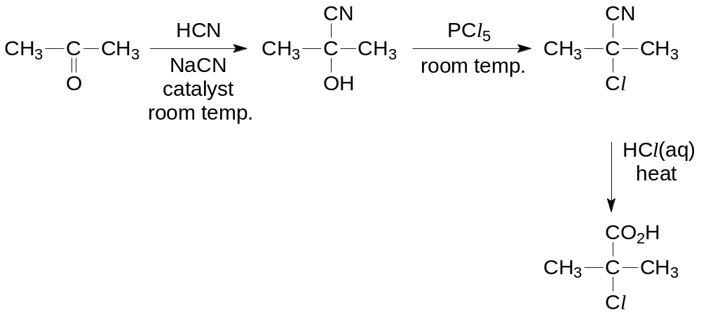
[Steps 2 and 3 can be interchanged.]

